# Installation of NOAH Tool

The following are required before you can install and run the program.

* Installation of Python (tested on version 3.6.7 but newer versions might also work)
* Python should be set in System environment variables   
  This is done by following the steps below (Pictures taken from <https://datatofish.com/add-python-to-windows-path/>):

Open Properties in This PC

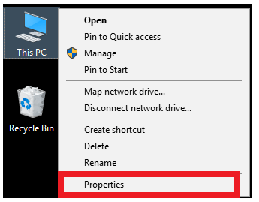

Open Advanced System Settings

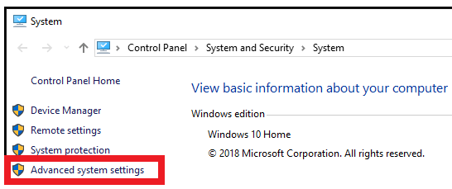

Open Environment Variables

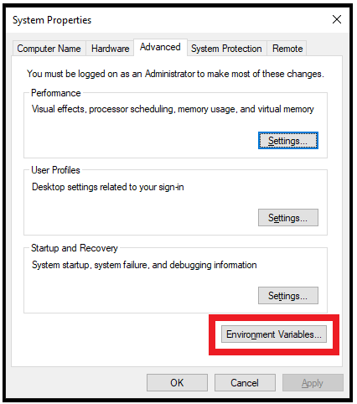

Select New

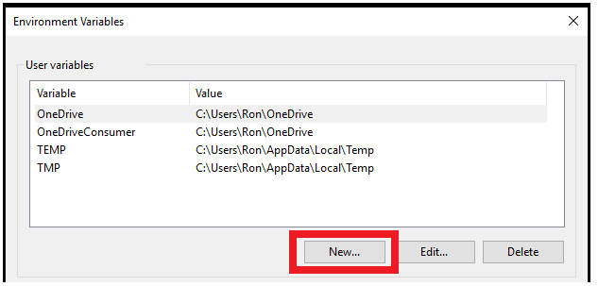

The following window will appear

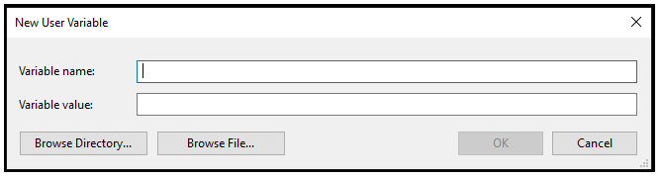

In the New User Variable window type in a name for the Variable (e.g Path).

In the “Variable value” field two paths are required.

The first is the path of your python installation:

Locate your Python installation and copy the path. The window should look like below

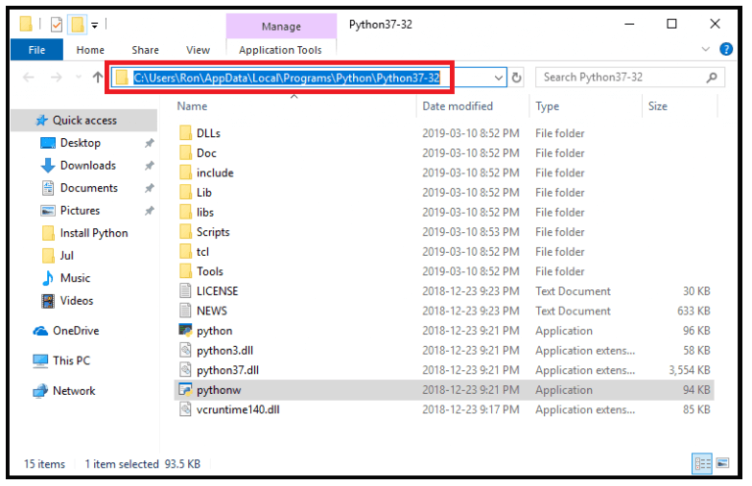

and insert the copied path as the first variable value.

Put a ; and insert the path again followed by “\Scripts”. This is the second path.

The “Variable value” should look like: *copied_path*;*copied_path*\Scripts as the picture below.

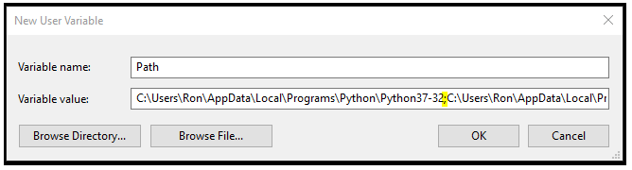

The new variable can now be seen.

Click OK and you are done.

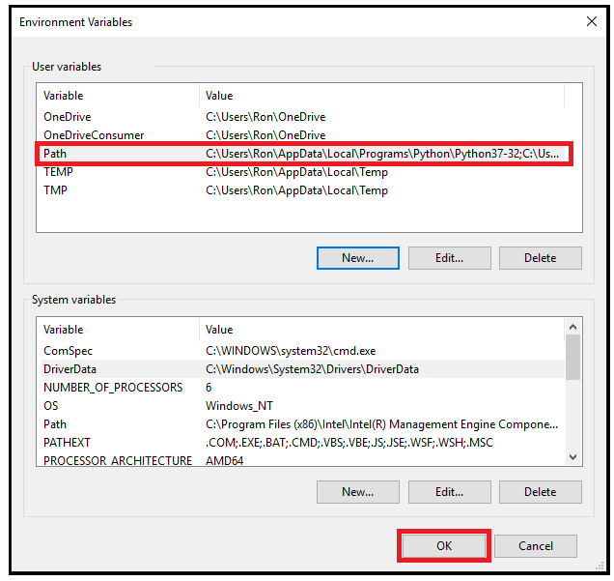

* Clone the NOAH repository to a location on your computer. (<https://github.com/mbjjo/NOAH>)

To install the program, double click the *install* batchfile.

To execute the program, double click the *Run* batchfile.

All *print* statements and user massages will be shown in the windows console that appear in the background. If warnings occur or the program crashes the errors will be shown here.

Note that when the program is running it will be “not responding”. This means that simulations are running in the background. The status can be seen in the windows console.

It is necessary to copy any external files (such a rain data) to the *NOAH_RTC_Tool/lib* directory.